2014학년도 2학기 Course Syllabus Basics
Name of the  professor | 데미안헤이우드
Purpose of the  Teaching & Learning | The course starts with some different types of logical paragraph writing and then moves onto academic essays and research methodology. Students are to be able to structure and write an academic essay
Textbook and  the reference | I provide all the materials from a variety of book and web sources.  http://profdamian.weebly.com  n01487477@gmail.com ; damian_donga@hotmail.com ; n01487477@hotmail.com ;  ph. 010-4871-1066
Method of the  Lecture evaluation | Paragraph writing.  Extended Paragraph writing.  Academic Essay.  Class participation.
NB*** | All work sent to me via email needs to be in *.doc format. ANY and ALL *.hwp files will be sent back to you unmarked.  The email should contain your name, student no and whether this is a draft or final submission.
Utilizing of the
Lecture Evaluation

Assessment
1. Attendance and Participation – 10%
2. Opinion paragraph – 5% (Due 11 September)
3. Logical paragraph – 5% (Due 18 September)
4. Thesis paragraph with planned structure – 10% (Due 2nd October)
5. Thesis paragraph + Research paragraphs – 10% (Due 16 October)
6. Thesis paragraph + Research paragraphs + conclusion – 20% (Due 30th October (?))
7. Main Research paper – 40% (Due – 11-18 December (?))
Course Schedule
Week | Subject | Contents of the Lecture | Teaching Process | Assignment | 수정
1 | Welcome & Course Outline. | Welcome & Course Outline. Argumentation and Paragraph Review | Oral and written, course materials | Opinion Paragraph.
2 | Paragraphing | Paragraphing - clarity, unity and coherence & logical Ordering | Oral and written, course materials | Logical Paragraph
3 | Thesis Paragraphing | Hooks, Thesis statements, and argument. | Oral and written, course materials
4 | Thesis Paragraphing | (cont'd) | Oral and written, course materials | Thesis Paragraph with planned structure
5 | Research | Supporting Evidence, Research methodology, quoting, summarization & idea referencing | Oral and written, course materials
6 | Research | (cont'd) | Oral and written, course materials
7 | Mini Essays - conclusions. | Thesis Paragraph, planned structure, concluding paragraphs | Oral and written, course materials | Thesis statement + Research Paragraph(s)
8 | Mid-Term exams | None | None
9 | From Paragraphs to Essays | Modeling the final Essay | Oral and written, course materials | Thesis with planned structure, conclusion
10 | Essay Structures and style |  | Course materials, Oral and written
11 | Research methodology, referencing and bibliography |  | Course materials, oral and written
12 | Counter-Arguments |  | Course materials, oral and written
13 | Interpretation and drawing conclusions |  | Oral and written, course materials
14 | Course wrap up and Peer Review
15 | Consultation & Review
16 | Final exams |  |  | Final Researched Academic Essay Due

Week 1 – Argumentation and paragraphing.
Lesson Structure
1. Introductions and syllabus.
2. Paragraph review + examples
3. Argumentation (spoken and written)
4. Assignment
Ex. 1
Busan is a great place to live. The local cuisine is incredible. It includes spicy street food, raw seafood, and smoky pigs feet. It is also a beautiful place, with majestic mountains and warm, sunny beaches. And the people are so friendly. Complete strangers often stop to chat with foreigners or ask them if they need help. This has happened to me. These are just some of the reasons I think Busan is a fantastic place to live.
Ex. 2
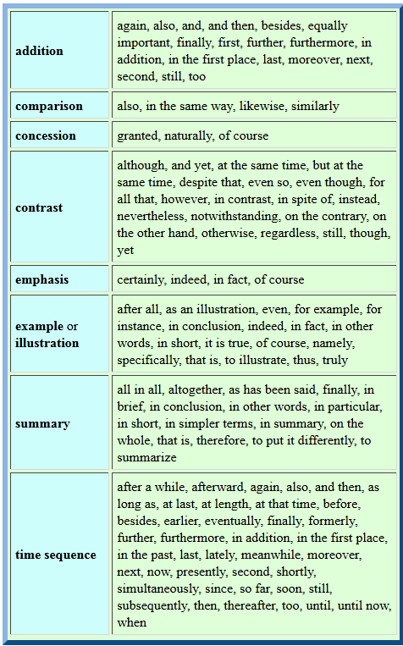
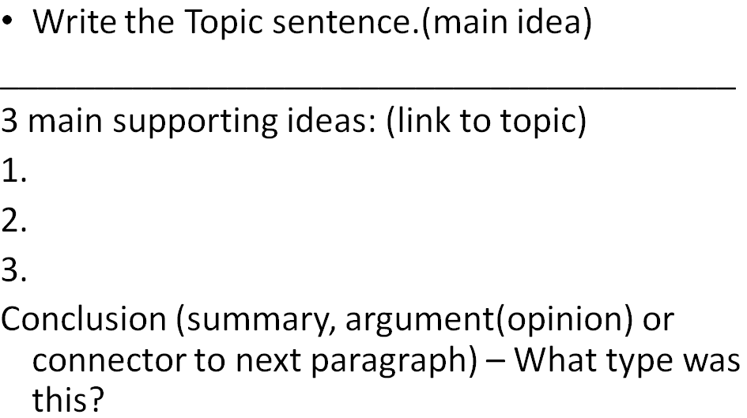
There are three reasons I don’t have a credit card. The first reason is that using a piece of plastic instead of cash makes it too easy for me to buy things I can’t afford. For instance, last week I saw a $75.00 pair of pink sandals in my favorite shoe store. Of course, I don’t need pink sandals, nor can I afford them. With a credit card, however, I would now own those sandals and be worrying about how to pay for them. The second reason I don’t have a credit card is that I would end up in debt like my friend Sara the shopaholic. Sara got a credit last year, and she already owes $4,000. She buys things that she doesn’t really need such as jewelry and designer sunglasses. Sara makes only minimum payments, so her balance never decreases. She will be in debt for years. The third reason I don’t have a credit card is the difficulty in understanding the fine print in the credit card contract. If I don’t read the fine print, I can be surprised. For example, some credit companies will raise my interest rate if I make payment even one day late. To sum up, credit cards may be a convenience for some people, but for me, they are plastic ticket to financial disaster.
Looking from all sides: Discussion -> argument -> rebuttal - >
1. Focus Q - Argument
- What are some reason why people argue?
- What does your family argue about? Friends?
- In your opinion is being argumentative a positive trait or a flaw?
- Are there any benefits to arguing? Do you think it is best to argue or just walk away? Shy?
- Are you passionate about your beliefs? Are you easily persuaded in an argument?
- Do you get along with argumentative people? Do you feel bad after you have an argument?
- Do you steer clear of some touchy topics or do you get a kick out of provoking others?
- Do you ever try to impose your beliefs on others?
- Do you at times enjoy "playing the devil's advocate" (debating for the fun of it)?
- Do you think it's disrespectful to argue with your elders?

2. Giving opinions and reasons

Opinion statement | Reason
- I think (that), I agree (with), In my opinion, I'm for it, I'm in favour of it, The way I see it...  - If you want my honest opinion....  - According to Lisa...  - As far as I'm concerned...  - If you ask me... | Because, since, as, in view of the fact that, owing to the fact that, seeing (that/as), due to, through the following reasons, by reason of, etc
- I don't (think), I disagree (with), I'm against it, I'm opposed to it  - I don't think so.  - (strong) No way.  - I'm afraid I disagree.  - (strong) I totally disagree.  - I beg to differ.  - (strong) I'd say the exact opposite.  - Not necessarily.  - That's not always true.  - That's not always the case.  - No, I'm not so sure about that | + statement of logical fact.

A. What do you think about … Smoking in public places?
B. I think it's bad because other people have to smell others smoke! (What about you? / How do you feel (about it / topic sentence)? / Don't you think? / Isn't it true? )
A. Oh - I agree / disagree with you because ...
B. (Additionally, Next, Also, Secondly, Furthermore, Another point I want to bring up is)…
Try these
Alcohol ban on campus | Increasing Govt. welfare | Single parenting
Bullying is a part of life | The link between Video games and violence. | Everyone is basically selfish
Uni Food / Uni facilities / Uni help in finding employment etc | Travelling abroad for English education. | Integrated classrooms with special needs students
Drinking in public places | Dating someone in your major or who you work with. | Men having to pay and plan social activities for girls.
Military service for men & women. | Living with someone before marriage. | (Your choice)

**NB - We are looking for a thesis statement and 2-3 supporting facts or reasons.

Now to writing a simple opinion paragraph.

ELEMENTS OF ARGUMENT
1. Fact vs. Opinion
Facts can be proven, while opinions are personal feelings about a topic. Argument writers use both fact and
opinion when developing pieces.
2. What Is an Argument?
An argument is an opinion supported by facts. Writers refer to opinions as claims and facts as evidence. The
claim clearly states a stance on a topic or issue. Evidence to prove this claim can include reasons, personal
experience, statistics, confirmed facts, and expert research.

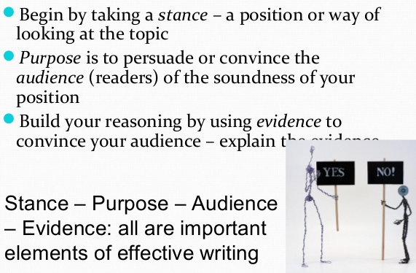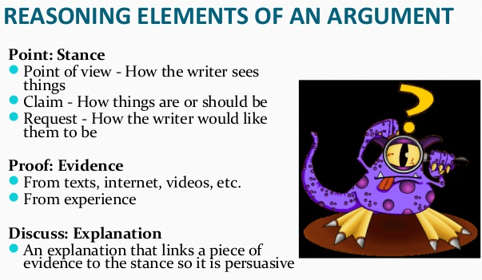
Plan
Topic Sentence
Point 1
- support
Point 2
-support
Point 3
-support

